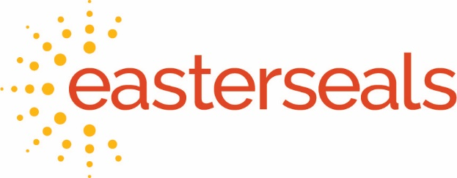
MEDIA CONTACT:
(Include contact name, email address, and cell phone number
as well as Affiliate name here)

FOR IMMEDIATE RELEASE

Easterseals Releases Comprehensive Study on the Impact of COVID-19 on People with Disabilities
Organization Presents Roadmap Forward to Address the National Crisis
Post-Pandemic for 61 Million Americans with Disabilities including Thousands Living in (Affiliate Territory)

CHICAGO, MAY 4, 2021 -- Easterseals, a leading national nonprofit provider of outcomes-based services and powerful advocacy for people with disabilities, today released its Easterseals Study on the Impact of COVID-19 on People with Disabilities. The organization will use the findings as a dynamic roadmap forward, launching a comprehensive, nationwide strategic effort to modify, expand, and amplify its services to respond to the urgent and evolving needs of the many children, adults and families it serves.

“Before COVID-19, people with disabilities were already at a disadvantage. While it is no surprise, 2020 was a difficult year for virtually every American. But for the 61 million people living with disabilities in our country, and the thousands living in (Affiliate territory), there is no doubt that they have been hit disproportionately hard by the crisis,” says (Affiliate CEO name, title) of Easterseals (Affiliate name). “For most in the disability community, the barriers to recovery are more complex and, if not properly addressed, will have immediate and long-term consequences on their quality of life and wellbeing, not to mention a negative impact on society at large.”

Study topline results and key findings reinforce current insights on access, inclusion, and equity in healthcare, employment, and education for children and adults with disabilities including veterans and seniors, as well as their families and caregivers. Grounded in this current data, the Study allows for Easterseals to respond with informed solutions, providing the organization with qualitative and quantitative research to galvanize national, state and local government officials, as well as corporate leaders and individual donors, to partner with Easterseals (Affiliate name) to change the landscape for people with disabilities and ensure greater equity and inclusion for them in the post-pandemic world.

-MORE-

“It is essential, especially at this critical point in the recovery of our nation and our community, that people with disabilities are given every opportunity to successfully rebound, rebuild, and fully participate in their communities,” adds (Affiliate CEO last name). “The Study informs Easterseals’ response and path forward to make sure every one of us is included and deeply valued in (Affiliate territory).”

Made possible through support from a transformational gift to the National Office of Easterseals by philanthropist MacKenzie Scott in late 2020, the Study confirms Ms. Scott’s belief that certain marginalized communities, including people with disabilities, would bear the brunt of the pandemic and would disproportionately experience negative effects across all aspects of their lives but particularly around healthcare equity, education, employment, and financial stability.

Services provided by Easterseals (Affiliate name), including (listing of key services provided by Affiliate) position it to respond locally to a number of disparities identified in the Study. “The needs are great,” states (Affiliate CEO last name). “But we are committed to work with other community partners who share our belief in a more just and equitable community post-pandemic to ensure that children and adults with disabilities are not left behind and have access to the rights and opportunities that others in our community enjoy.” (Note: can be tailored with other messaging by Affiliate).

Easterseals commissioned Accenture, a global professional services company, to conduct in-depth interviews, fielded online from January 18 to April 9, 2021. This included a cross section of nearly 1,000 individuals within the Easterseals Network including volunteer and staff leadership from its 67 Affiliates nationwide as well as individuals with disabilities throughout the lifespan (including people of color with disabilities), their parents, and their caregivers. Secondary data reflecting how COVID-19 has exacerbated challenges for people with disabilities is also included in the Study.

View the entire study here.
###

About Easterseals
Driven by its purpose to change the way the world defines and views disability, Easterseals makes profound, positive differences in the lives of people with disabilities every day through its life-changing services and powerful advocacy. For more than 100 years, Easterseals has been an indispensable resource for children and adults with disabilities, veterans, seniors, their families and their communities. Together, its national network of 67 affiliates serves 1.5 million people annually through high-quality community- and home-based services that include early intervention; autism services; workforce development programs; medical rehabilitation, including physical, occupational and speech therapies; behavioral health services; adult day programs; and much more. In schools, workplaces, and communities, Easterseals is fostering environments where everyone is included and valued – making a real and positive impact on us all. Join us in ensuring that everyone – regardless of age or ability – is 100% included and 100% empowered to reach their potential and participate in society. Learn more at www.easterseals.com.

Insert Affiliate Boiler Plate Here

