- Easterseals Arc has developed this protocol based on guidance from the Centers for Disease Control and Prevention, Indiana and Allen County Departments of Health, and the Division of Disability and Rehabilitative Services. As the Coronavirus is an evolving situation, this protocol is subject to change as new guidance becomes available.
SCOPE: The scope of this guidance includes all staff, participants and programs/services, executed at both 4919 Coldwater Road and 4919 Projects Drive, Fort Wayne, Ind., 46825.
VISITOR RESTRICTION: During the COVID-19 pandemic, Easterseals Arc is limiting public access at all day service locations to only Easterseals Arc’s staff and participants. We ask that any individual who is not an Easterseals Arc employee or participant visit with participants outside of day service hours. In the case of emergencies in which outside individuals need face-to-face access to Easterseals Arc’s participants or staff, the visitor must follow the procedure outlined below.
- Visitor must check-in with Easterseals Arc’s receptionist or designee
  - During check-in all visitors will be REQUIRED to go through a screening of questions as well as a temperature check prior to entering the building.
    - Any visitor that refuses to go through the screening or has an elevated temperature of 100°F or higher will not be admitted into the facility and will be asked to leave.
    - A message can be taken and delivered to the participant or staff if the visitor chooses.
- Once the visitor has passed the screening, they must provide the receptionist/designee with the first and last name of the participant or staff they are visiting.
- The receptionist/designee will contact the appropriate person to have the participant or staff notified of their visitor.
- The participant or staff will come to the lobby and visit with their guest.
  - If privacy is needed, a conference room can be scheduled with the receptionist/designee.
MODIFIED PROGRAM HOURS: All programs operating from 4919 Coldwater Road and 4919 Projects Drive will have modified operating hours until further notice. These hours will be 7:30 a.m. to 4 p.m.
ARRIVAL/DISMISSAL (STAFF): All staff will enter the building via the main visitor’s entrance (Coldwater location- door #9; Projects Drive location- door #2). Upon arrival, all staff will go through the REQUIRED screening of questions and temperature check prior to admission to their work area. If staff refuse to go through the REQUIRED screening, they will not be allowed into their work area, and the program director will be contacted.
- The program director will inform the staff of the consequences of non-compliance, and if they still refuse, the staff will be sent home and their benefit time will be used.
  - The absence will count toward Easterseals Arc’s attendance policy outlined in the employee handbook (pg. 40-41), and disciplinary action could follow.
ANY staff who has an elevated temperature of 100°F or higher will not be allowed into their work area. They will be instructed to go home and contact their medical provider for further instructions. The staff’s supervisor will follow up within 24 hours to get an update and any additional instructions that were given from the medical provider.
- Staff will utilize their benefit time and this absence will NOT count negatively against Easterseals Arc’s attendance policy.
Prior to entering designated work areas, ALL staff are required to wash or sanitize their hands (this should be done right after screening), sign into PROCARE, and wear the appropriate PPE (face mask) during their entire shift.
- Any staff who refuses to wear a face mask will be asked to leave for non-compliance, and their benefit time will be used, and disciplinary action could follow.
  - The absence will count towards Easterseals Arc’s attendance policy outline in the employee handbook (pg. 40-41).
When leaving for the day, staff will need to sign out of PROCARE as well as signing out on the screening sheet.
ARRIVAL/DISMISSAL (PARTICIPANTS): Upon arrival, an Easterseals Arc employee will meet each participant at the door or their vehicle. Prior to having access to their work area/classroom, each participant will have their temperature checked. Best practice will be to check temperatures prior to individuals exiting their transportation. If this cannot be done in a safe and efficient manner, each location will have a designated holding area (that allows for 6 foot spacing between individuals) that participants will go to get their temperatures checked prior to entering their work area/classroom. Please note, this area should be isolated from frequently used areas if possible.
- 4919 Project Drive Group: Cafeteria
- 4919 Coldwater Road: Hall area at door #12
ANY participant who has a temperature of 100°F or higher and/or displays any of the symptoms below will not be permitted to attend day services and will be sent home to consult their healthcare provider.
- Respiratory issues
- Coughing
- Shortness of breath
- Diarrhea
An Easterseals Arc supervisor will follow up within 24 hours to get an update. If no further instructions are given by the healthcare provider, participants will be able to return to programming after all symptoms have subsided and/or THREE DAY (72 HOURS) have passed since recovery, which is defined as resolution of fever without the use of fever-reducing medications.
Prior to admission to their work area/classroom, each participant will be asked to wear a mask during programming hours (if tolerated by the participant) and wash/sanitize their hands.
For program dismissal, Easterseals Arc’s staff will coordinate individuals getting to their respective transportation. For the 4919 Projects Drive location, the traditional Jean Drive pickup process will be utilized for all participants. For the 4919 Coldwater Road location, the typical “bus duty” process will apply for all individuals using transit transportation (Citilink, Community Transportation Network, Access). For individuals who receive transportation from family/caregivers, the following process should be followed:
- Family/caregiver will need to enter through the respective visitors’ entrance (door #9) and go through the screening prior to entering.
  - If family/caregiver has a temperature of 100°F or higher, they will not be permitted into the building and will be asked to wait in their vehicle for an Easterseals Arc staff to bring their participant out.
- Family/caregiver will give the receptionist/designee the first and last name of the participant they are picking up.
- Family/caregiver will wait in the lobby for their individuals.
- At NO TIME will a family/caregiver be permitted in the programming area without prior director’s approval.

PROGRAM OPERATIONS
Informed Consent: Each participant who attends Easterseals Arc’s day programs will have a signed informed consent on file prior to start date.
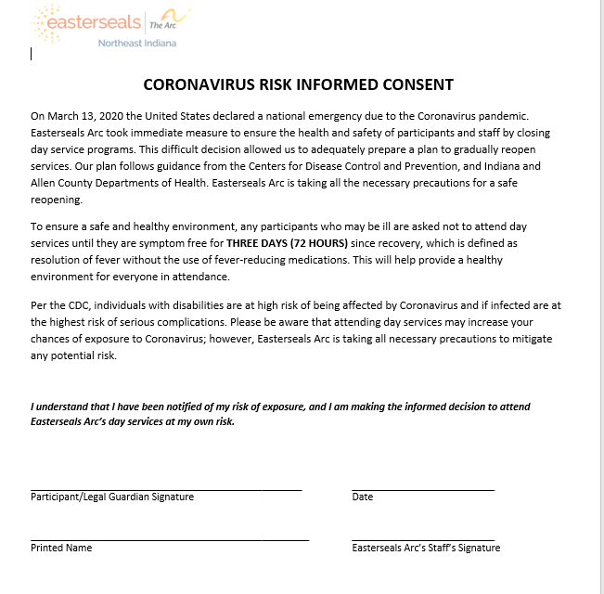
Social Distancing: Each program will always work to ensure social distancing to our fullest potential. Each work area/classroom will strive to ensure adequate spacing (6 feet) between each participant and staff. To help achieve this spacing, all services within 4919 Coldwater Road and 4919 Projects Drive locations will operate at ratios of 4 participants to 1 staff per area/classroom. At the discretion of the program’s director, adjustment can be made to ratios if social distancing (6 foot spacing) and a maximum of 10 individuals in one location/classroom can be executed safely. Any adjustments to rations should be done as a last resort when all other options have been explored. When possible, participants should not be moved to different staff and rooms throughout the day. The best efforts will be made to avoid staffing changes with participants during operating hours.
Handwashing: Handwashing will be implemented for staff and participants no less than 4 times a day during programming (this is in addition to the initial handwashing required upon arrival). Handwashing should follow the guidelines set forth by the Centers for Disease Control and Prevention, which is listed below and will be posted in each classroom/area.

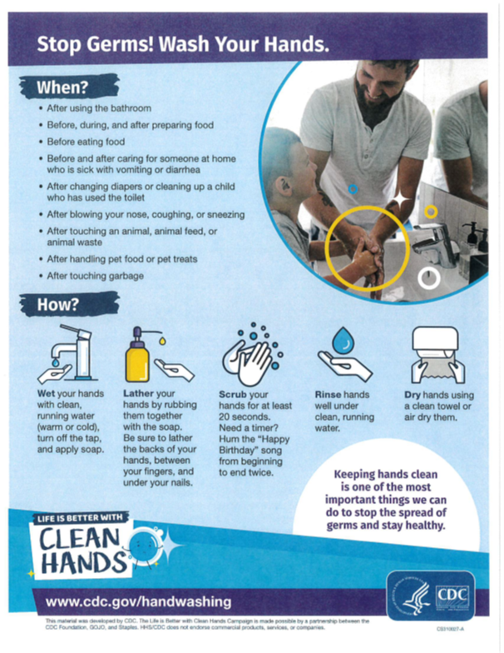

PPE: Staff as well as participants will receive face masks to be worn during programming hours. Staff providing direct care will wear SURGICAL MASK while participants will be given cloth mask (housed at Easterseals Arc). Staff not providing direct care will wear cloth mask. Each day the worn fabric face mask will be washed and sanitized according to CDC standards for washing fabric face mask.
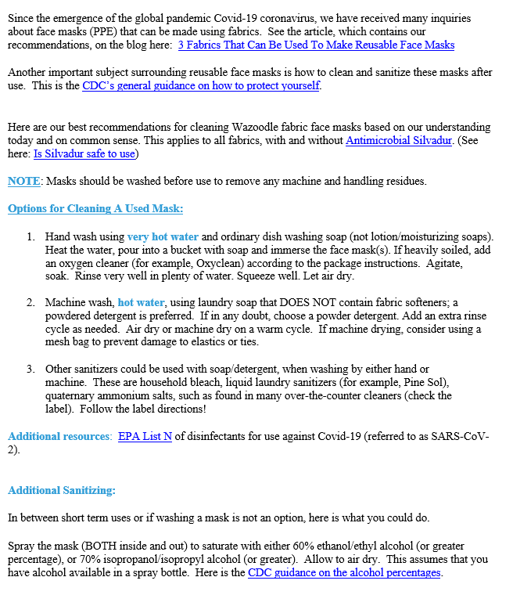

Symptom Tracking: Each participant who attends day programming will have a proactive COVID-19 symptom tracking form completed each day. This tracking will be evaluated twice a day by supervisor, director or designee. Program supervisor, director or designee will evaluate each symptom tracking form to ensure no symptoms are noted and submit to central files for uploading each month.
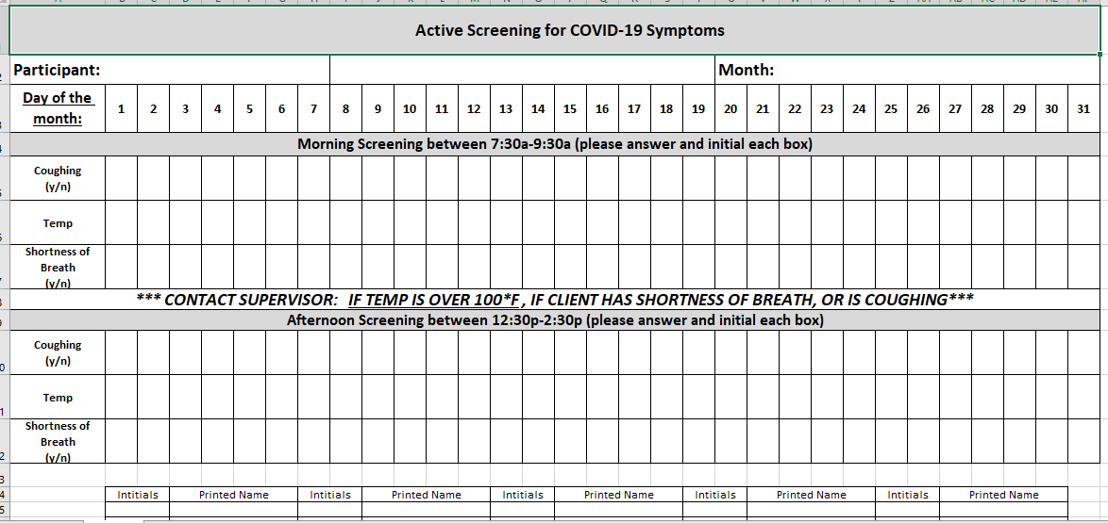

High Risk Participants: Considerations will be made on an individual basis regarding whether participants with vulnerabilities to COVID-19 should attend day programming. If Easterseals Arc feels the individual’s vulnerabilities are high and recommends the individual continue to shelter in place, communication will be given to the individual’s support team regarding recommendations or alternatives to in-person service delivery. Please note if any one individual has experienced symptoms parallel to COVID-19 within the last 14 days, they should not attend as well until they have been symptom free without any medication for at least 14 days. The following individuals will be considered vulnerable and high risk for contracting COVID-19:
- Adults aged 60 and older
- Those with serious chronic medical conditions such as:
  - Hearth disease
  - History of respiratory distress
  - Diabetes
  - Lung disease
Opening/Closing Disinfecting: To prevent the spread of COVID-19, each classroom/work area will have all shared spaces and high touch surfaces disinfected before operating hours (between 6 and 7:30 a.m.) and after operating hours (between 4 and 6 p.m.). This will be done by supervisors/designee of the area. Hospital grade disinfectant, alcohol solutions (70% or higher) or household bleach solution will be used. The diluted household bleach solution recommended by the CDC can be used as well (5 tablespoons (1/3rd cup) bleach per gallon of water or 4 teaspoons bleach per quart of water). Each classroom also will have aerosol disinfecting air spray that will be used as well. Staff will use appropriate PPE while disinfecting (face mask and gloves). The following checklist will be implemented to ensure each room utilized is correctly disinfected:
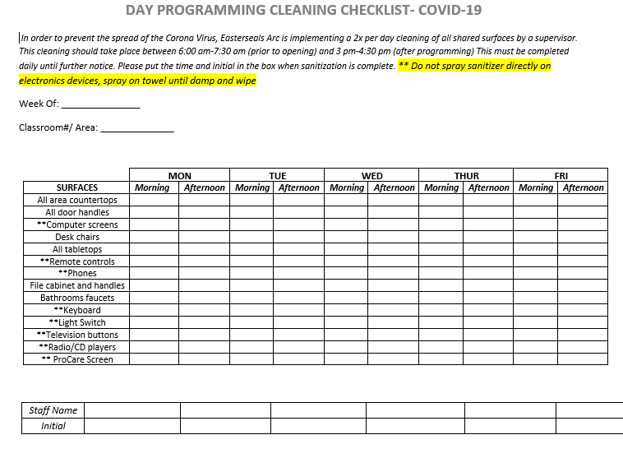

Disinfecting Sweep: Every 2 hours, each classroom/area will go through a disinfecting where they wipe off all surfaces and door handles. Supervisor/designee will make an announcement at 9am, 11am, 1pm and 3pm to inform classrooms/areas to do a sanitation sweep. They will use sanitation wipes or spray to do this. After each sanitation sweep, participants and staff should wash/sanitize their hands
Subcontract Disinfecting: All incoming and outgoing subcontract work will follow the sanitizing procedure for subcontract work.

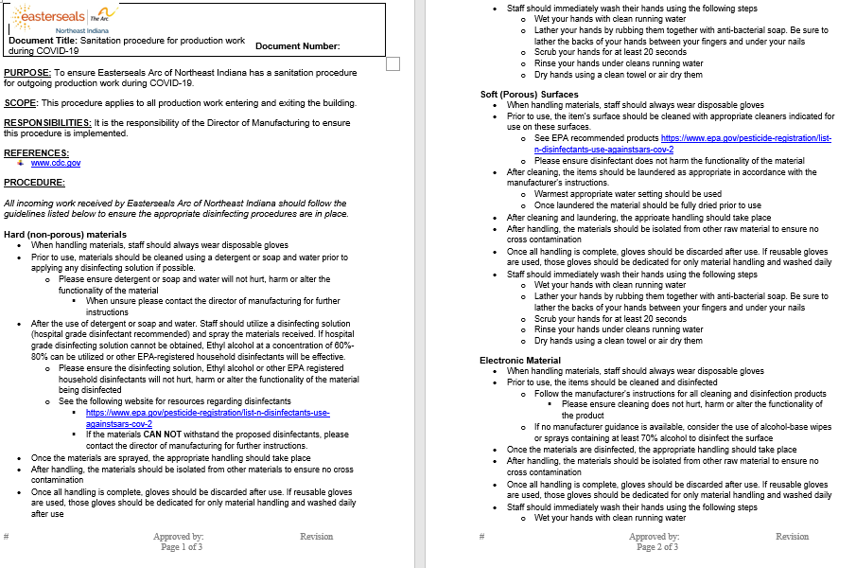

Signage: Each classroom/work area will have the following signage posted or available for staff to review:
- How to appropriately put on a mask**
- Coronavirus information for DSPs
- Proper handwashing signs**
- When to wash your hands**
- CDC cleaning guidelines
- Safety data sheet for hospital grade disinfectant** (if used)
- Day programming disinfecting checklist
**posted items
Outings/Community Experiences: All community-based experiences will be canceled until further notice for both locations due to COVID-19.
Appropriate Staffing: A letter will be sent to specific participants (least vulnerable) to get an estimate of attendance. Staffing will be based on participants in groups of 4:1 at each location until further notice. Each classroom/ work area will operate in this 4:1 ratio (4 participants to 1 staff). If at any time additional staffing is needed to support 4:1 ratio, the program’s supervisor as well as the program director/assistant director will be deployed as staff. Scheduling for ratios and staffing will be done the day prior to ensure levels are adequate to support. If a direct staff must leave work for any reason, the program supervisor must cover the group to prevent shifting of clients and participants and reducing the number of individuals who could potentially be exposed.
**Ratios can only be adjusted as a last resort when all other options have been explored. The adjustment will be made by the program director.
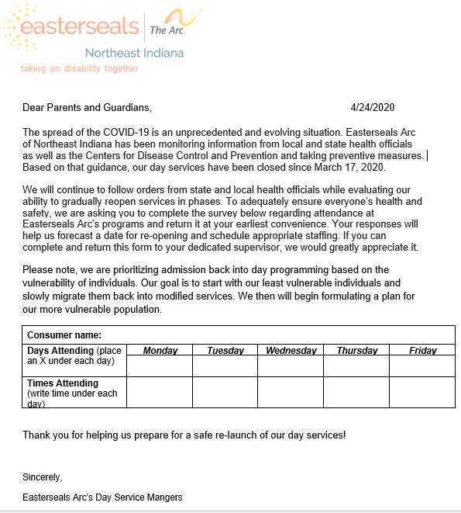

Staff Training: Prior to reopening, staff working in all Easterseals Arc day service locations will have training on the following. Staff will have a competency base test as well. Staff will need to receive an 80% on the test to ensure competency.
- Social distancing
- Isolation area per site
- Isolation kits
- Disinfecting routine
- Universal precautions
- Staff arrival/dismissal plan
- Client arrival/dismissal plan
- Symptom tracking
- Visitor restrictions
- Handwashing
- Ratios
- Putting on/removing PPE
Participant Training/Skill building- Upon return, participants will be trained on the following topics. Participants will complete a competency base test (those who are able to complete) to prove understanding.
- What is COVID-19
- Symptoms
- Social distancing
- Handwashing
- Wearing masks
- New program operations
  - Lunches
  - Vending machines
  - Outings
Bathroom Usage- Each area/classroom’s staff and participants will have a designated bathroom they will utilized to mitigate any cross contamination.
Floor markers- All common and heavily congregated areas will have designated markers highlighting six foot spacing. Staff and participants should recognize and ensure they are abiding by the 6-foot spacing.

Potential Exposure/Exposure Outbreak
Isolation Area: Each location (4919 Coldwater Road and 4919 Projects Drive) will have a designated isolation room. This room will be used for any staff or participant who develops the following symptoms during programming hours:
**These rooms will remain locked until there is a need for use.
- 100°F or higher
- Respiratory issues
- Coughing
- Shortness of breath
- Diarrhea
Or at least two of the following
- Fever
- Chills
- Sore throat
- New loss of taste or smell
- Muscle Pain
- Shaking with chills

4919 Coldwater Road Isolation Site: Room 222
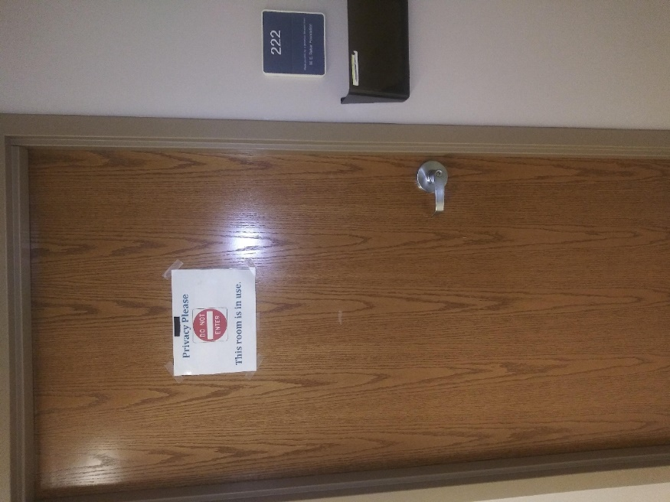

4919 Projects Drive Isolation Site:
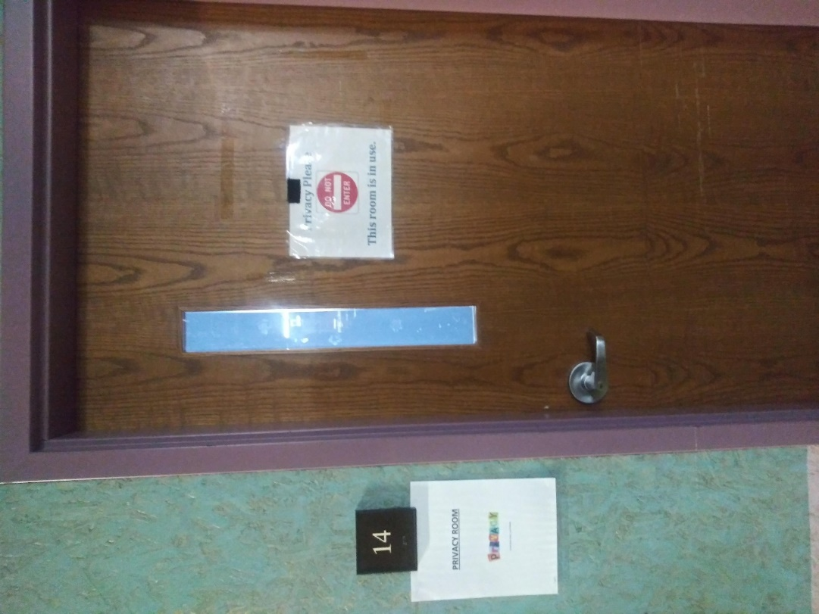
Isolation Kits: Each location will have isolation kits available. The items in each kit consist on the following
- Disposal gloves
- Surgical Face Mask
- Disposal gowns
- Goggles
- Hospital grade disinfectant
- Plastic garbage bags
- Paper towels/ disposal towels
- Disinfectant Spray
- Donning/Doffing instructions
Staff/participants are to stay in the isolation areas until they are ready to leave. For participants who must be Isolated prior to transportation arriving, designated staff will be responsible for supervision. Designated staff will put on appropriate PPE and stay at least 6 feet from the participant until transportation arrives. If during this time, symptoms worsen and warrant immediate attention, 911 should be called.
An Easterseals Arc supervisor will follow up within 24 hours to get an update. If no further instructions are given by the healthcare provider, participants/staff will be able to return to programming after all symptoms have subsided and THREE DAY (72 HOURS) have passed since recovery, which is defined as resolution of fever without the use of fever-reducing medications.
Response to participant being tested for COVID-19
- Program supervisor/manager will maintain DAILY communication with participant until test results are available.
- Program supervisor/manager will contact the participant’s case manager and inform them of the participant being tested for COVID-19. Case manager will submit the required information to BDDS.
- Any staff or participant that was in contact with the tested individual will be instructed to monitor their symptoms for 14 days after last contact. If symptoms arise, they should contact their medical provider and Easterseals Arc. **If symptoms arise, they should NOT attend programming
- If test comes back NEGATIVE, participant can return to programming after they have been symptom free for 72 hours without any use of fever-reducing medication.
- If test come back POSITIVE, participant should not return to day programming until cleared by a medical professional.
- Consistent communication with the participant’s team for updates will be expected by the program QIDP.
Response to staff being tested for COVID-19
- Staff will remain off work until results are available.
- Program supervisor/manager will maintain DAILY communication with staff.
- Any staff or participant who was in contact with the tested individual will be instructed to monitor their symptoms for 14 days after last contact. If symptoms arise, they should contact their medical provider and Easterseals Arc. **If symptoms arise, they should NOT attend work
- If testing comes back NEGATIVE, staff can return to programming after they have been symptom free for 72 hours without any use of fever-reducing medication
- If testing comes back POSITIVE, staff will remain off and follow the instructions of their medical provider.
  - Staff will be paid with their benefit time and the absences WILL NOT count negatively against them.
- Staff may return to work after they are cleared by their healthcare provider and/or they meet the following guidance
  - At least three days (72 hours) have passed since recovery, which is defined as resolution of fever without the use of fever-reducing medications; AND
  - Improvement in his respiratory symptoms AND
  - At least seven days have passed since symptoms first appeared.

Transportation- Transportation for individuals to and from day programming will be modified until further notice to accommodate the following
- Each bus will house no more than 4 individuals at a time (ensuring 6-foot distance between each rider)
- Drivers will wear the appropriate PPE while transporting
- Daily disinfecting before and after each route will implemented

- Disinfecting of all seats and backrest | - Mopping of bus floor
- Sweeping of the floors | - Spraying of disinfectant
- Disinfecting of all rails | - Disinfecting of lift
- Disinfecting of high touch areas by driver | - Disinfecting of windows

Lunch- Each location will allow participants and staff to eat within their classroom/work area. All breakrooms/lunchrooms will be closed until further notice. The use of microwaves, vending machines and refrigerators will be prohibited. Staff and participants will be encouraged to bring lunch items that do not need warmed or cooled.
** Adult Day Center contracts meals through Fort Wayne Community Schools Nutrition division for CACFP. Until further notice, all meals will be individually packaged by Fort Wayne Community Schools and family style dinning will be discontinued as well until further notice.

REPORT A POSITIVE OR SUSPECTED COVID-19 DIAGNOSED EMPLOYEE
Any staff illnesses or deaths that are confirmed or suspected to be related to COVID-19 must be reported immediately to the vice president of employment and community supports. This information will be submitted to BDDS via
  - https://forms.office.com/Pages/ResponsePage.aspx?id=ur-ZIQmkE0-wxBi0WTPYjdeGrSGv-DlHozfF9fg56KdUNVZFWUc3Q0EzWjdWTlo0SkM0WFk4T1E2Qy4u
Process for reporting a suspected outbreak:
- In addition, a potential outbreak must be reported to the Allen County Department of Health (260-449-7561) and Indiana State Department of Health (317-233-1325). A potential outbreak is defined as a cluster of 3 or more individuals in the same location with respiratory illness, confirmed or suspected COVID-19. Staff and participants are included in the count. A potential outbreak in the facility will cause a shutdown for 48 hours or until the proper disinfecting can be performed, whichever is quickest. The Bureau of Quality Improvement Services also must be notified regarding the outbreak and closure of the facility via BQIS.Help@fssa.in.gov . The following information should be submitted to BQIS regarding the outbreak:
  - Number of individuals affected
  - Estimated duration of closure
  - Reason for closure
  - Alternative planning, if any
  - How individuals and families are/will be notified

How to clean/disinfect:
- Put on mask and gloves. Do not touch your face further.
- Prepare bleach solutions/disinfectant according to manufacturer instructions.
- Open windows (if applicable).
- Mop floor with bleach solution/disinfectant, from one end to the other.
- Soak cloths in bleach solution/disinfectant and use to wipe all frequently touched areas as well as toilet surfaces.
- Wash all cloths or linens within the area in a washing machine.
- Put all used cloths/rags and other waste into double-lined plastic trash bags.
- Remove gloves and wash your hands with soap and water.
- Remove mask and wash your hands with soap and water.
- Put used gloves and mask into double-lined plastic trash bag.
- Separate plastic trash bags generated from the cleanup from other area waste and throw them away as regular waste as soon as possible.
- Shower and change clothes immediately.
- Air/ventilate the area (fan, open windows, open doors).
** Please note this same process should be used when disinfecting each isolation room after use.

