2019 nCoV Screening in Ambulatory Settings

- Patient presents for appointment
- First point of contact screens patient for 2019 nCoV using Quick Screen

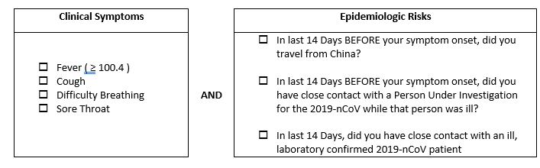

- If Patient screens
  - Negative-- continue with appointment
  - Positive
    - Mask patient with surgical mask (Provide masks to Family members accompanying patient)
    - Immediately escort patient to designated isolation room and CLOSE DOOR
    - Notify Clinician/Provider
- After patient is isolated and Clinician/Provider dons gown, mask (N95/PAPR if available), gloves, eye protection:
  - Instruct patient of need to go to ED for further evaluation (See Script)
  - Ask patient preference of ED
  - Call preferred ED
- Instruct patient to call ED number when they arrive in ED parking lot and await instruction
- Patients departs Ambulatory Setting/Physician Office for ED.
- Implement Cleaning processes for Designated Isolation Room
  - Keep door closed for 2 hours
  - Clean room 2 hours after patient departs
  - Clean room per standard protocol with an EPA-approved viral disinfectant. Examples include CaviWipes Bleach, CaviWipes1, Cavicide Bleach and CaviCide1

Sample Script for patient screening positive for 2019 -nCoV

Hello,

You were asked to wear a mask and put into a private room as a precaution, for your safety, the safety
of other patients and our staff. Although we believe the risk to the American public is low, the exact way the virus is spread is unknown so extra precautions are being put into place.

Due to your symptoms, travel to destinations in which the CDC has identified “widespread sustained transmission” or “sustained community transmission” of the virus, and/or possible exposure to the virus, we would like you to have additional testing. This testing must be done by the CDC to confirm if the virus is present. We cannot do the testing in this office so you need to go to the emergency room immediately. Please go straight to the ER without additional stops and continue to wear your mask while you are in public places or if you are in close contact with family/friends.

Please tell me which ER you will go to so we can be sure to call them and let them know you are on your way.

Local Emergency Room List
Site | Address | Contact Number

